DATE: January 23, 2025

TO: Keep Hayward Clean and Green Task Force

FROM: Maintenance Services Director

SUBJECT: Recommended Changes to Keep Hayward Clean and Green Task Force

RECOMMENDATION

That the Keep Hayward Clean and Green (KHCG) Task Force:

- Review the attached draft letter to the City Council’s Ad Hoc Committee on Boards and Commissions as prepared by the KHCG Policy Subcommittee.

- Take formal action to finalize and approve the letter for distribution to the Council’s Ad Hoc Committee on Boards and Commissions.

SUMMARY

Members of the KHCG Policy Subcommittee have prepared a draft letter addressed to the Council’s Ad Hoc Committee on Boards and Commissions that provides a recommendation to change KHCG from a Task Force to a Commission formally establishing the Clean and Green Commission.

BACKGROUND

The Council Ad Hoc Committee on Boards and Commissions met on November 13, 2024, to review and discuss recommendations on the Structure, Roles, and Uniform Operations of City Commissions. One of the primary recommendations is to confirm changes to the Keep Hayward Clean and Green Task Force, recognizing this group as a Commission-level body to be established as the Clean and Green Commission.

At the KHCG regular meeting of October 17, 2024, the KHCG Policy Subcommittee presented an oral report outlining the recommendations from the November 13, 2024, Council Ad Hoc Committee meeting, regarding changing the Task Force to a Commission. The Task Force request that staff schedule an action item on the January agenda to discuss and finalize a formal recommendation to the Council Ad Hoc Committee.

DISCUSSION

The KHCG Policy Subcommittee members met in December to discuss feedback from the October 17, 2024, KHCG meeting. After careful consideration the Polic Subcommittee recommends transitioning to a new, Clean and Green Commission. The subcommittee provided the attached draft letter to the Council’s Ad Hoc Committee outlining their recommendation to establish the Clean and Green Commission.

Please review the attached draft letter and provide feedback at the January 23, 2025, KHCG meeting. A formal recommendation should be sent to the Council Ad Hoc Committee for consideration in advance of their final recommendations which will be shared with the public at the March 4, 2025, City Council Meeting.

FISCAL AND ECONOMIC IMPACT

There is no fiscal or economic impact to send a letter of recommendation to Hayward City Council.

NEXT STEPS

Upon KHCG TF approval, the letter will be finalized and distributed to the Council Ad Hoc Committee.

Prepared by: Colleen Kamai, Administrative Supervisor

Recommended by: John Sanders, Streets Maintenance Manager

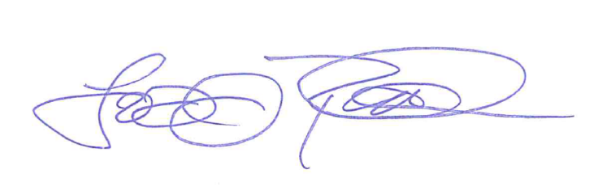
Approved by:

Todd Rullman, Maintenance Services Director

